Assignment for Linux - WEEK 2 Activity 3

What is Linux?
Linux, a robust and community-driven operating system inspired by Unix, embraces an open-source ethos. Its versatility extends across a plethora of computing platforms, ranging from traditional computers and servers to mobile and embedded devices. Enjoying widespread support, Linux stands as one of the most universally embraced operating systems. In the following document, we explore and showcase fundamental Linux commands using QTerminal tool. Though all these activities could be performed using the graphical user interface (GUI) but being a developer, we would be using Terminal Tools over GUI.
- Snapshot of the the Virtual Machine is taken with the name Snapshot 2. This helps in restoring the machine instance in case it is corrupt or some wrong doings are performed.
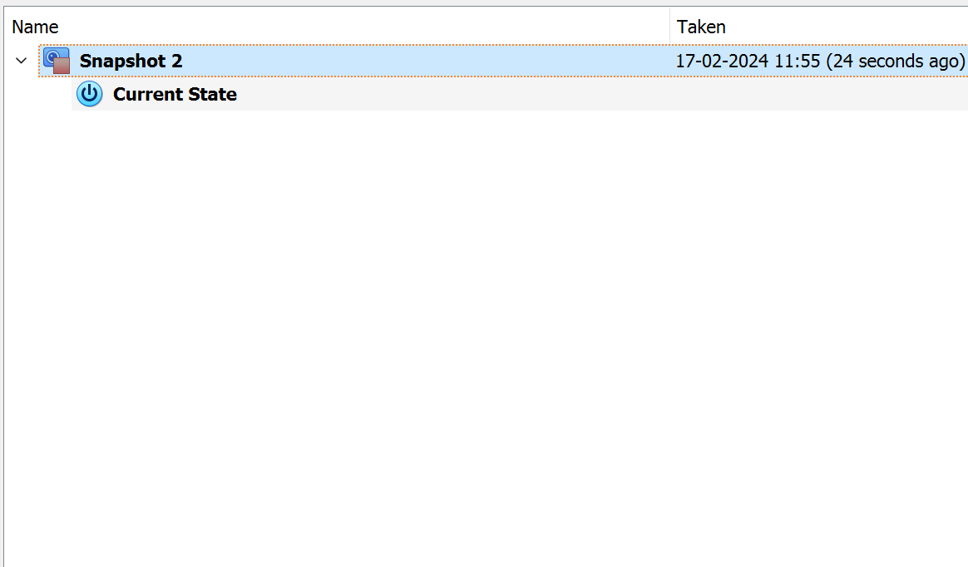
- Machine is logged In using the password.
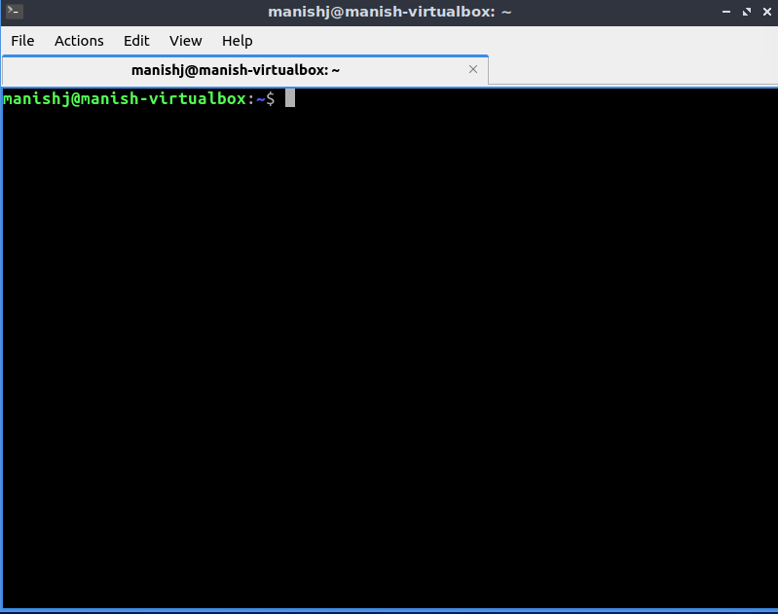

- CD command is used to change the directory into the newly created directory or home directory. In the below snapshot, we used the cd ~ command to reach the home directory.
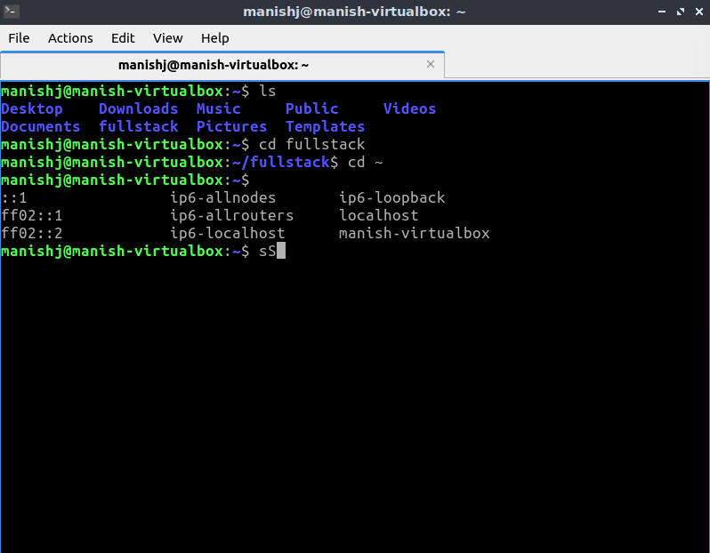

- PWD command is used to print the working directory details.
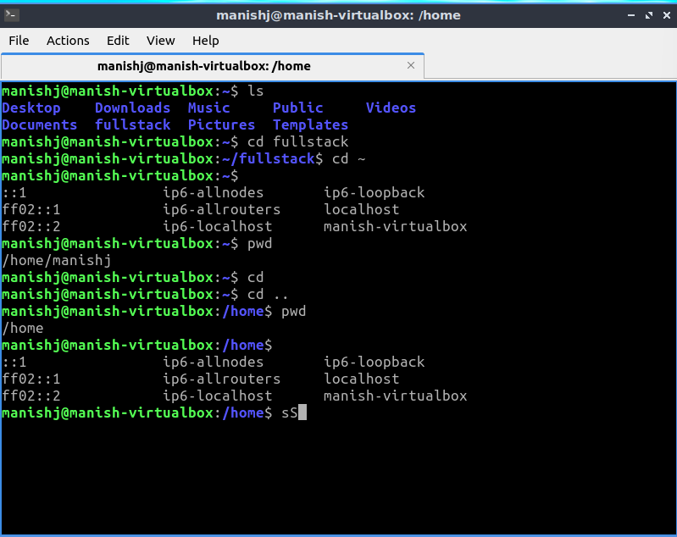
- MKDIR command is used to create new directory. In the snapshot below we created two directories named DEV and FULLSTACK.
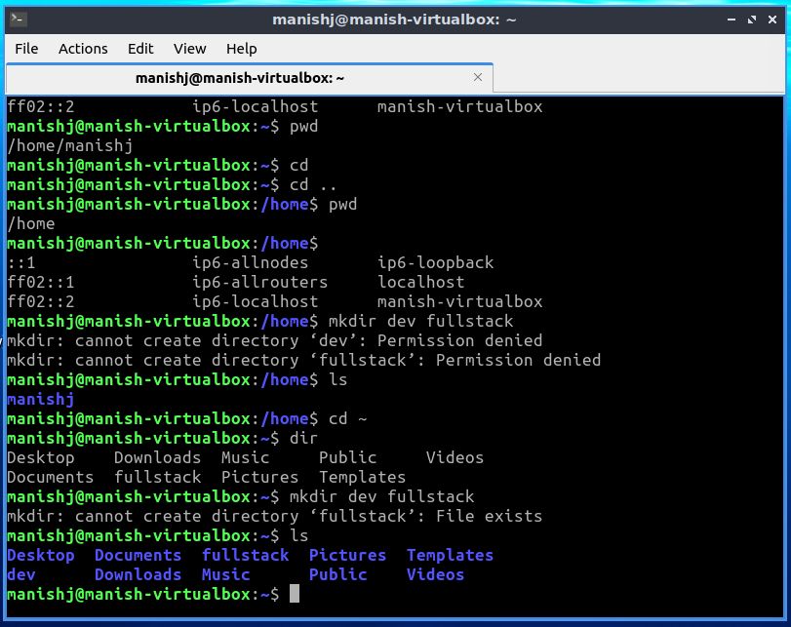
- TOUCH command is used to create the new files. In the below snapshot we created file.txt, file2.html and file.txt in the linux-exercises directory.
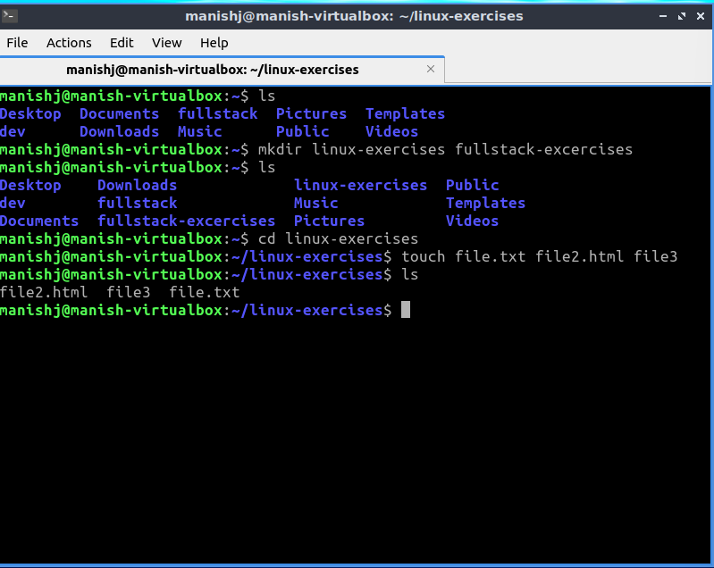
- CLEAR command is used to clear the terminal screen.
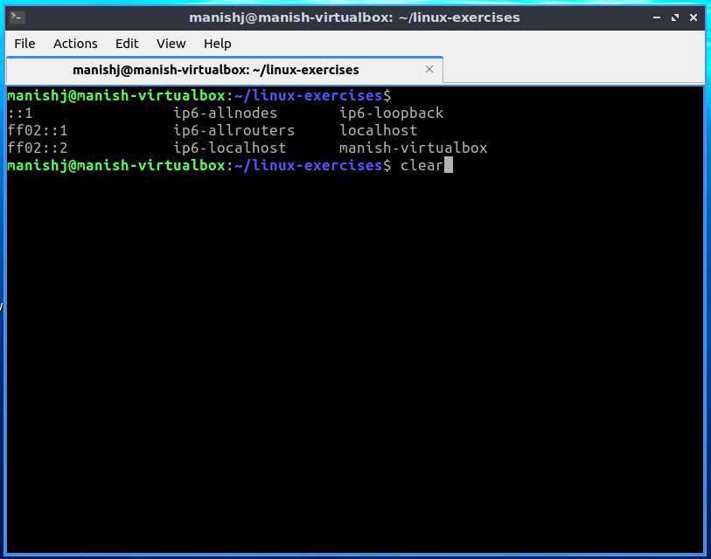

- ECHO command is used to add text to the files. In the below snapshot we used echo command to add text to the files file.txt, file2.html and file.
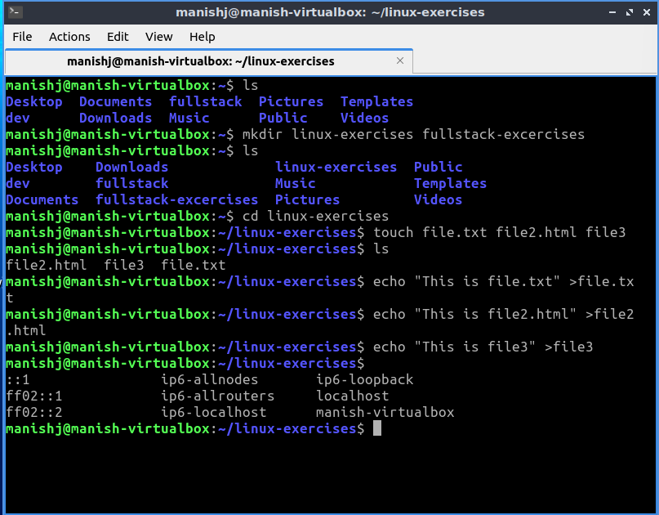

- CAT command is used to read the text in the files. In the below snapshot we used the cat command to read the text that we added in the point no. 8.
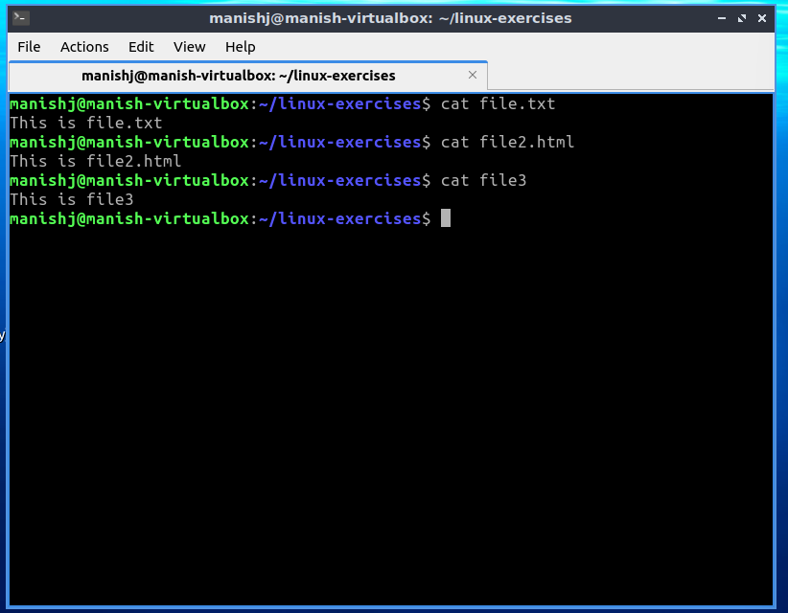
- MKDIR is used to create the new directories and RMDIR command is used to remove the directories. We used both the command to create and remove the TEST director.
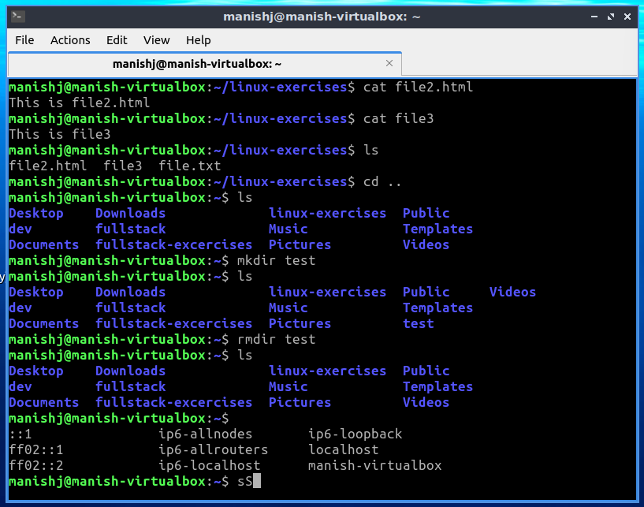

- CP and MV command is used to copy and move the files to some new or existing directory. In the snapshot below we demonstrated the same to copy and move in the newly created directory called DESTINATION_DIRECTORY.
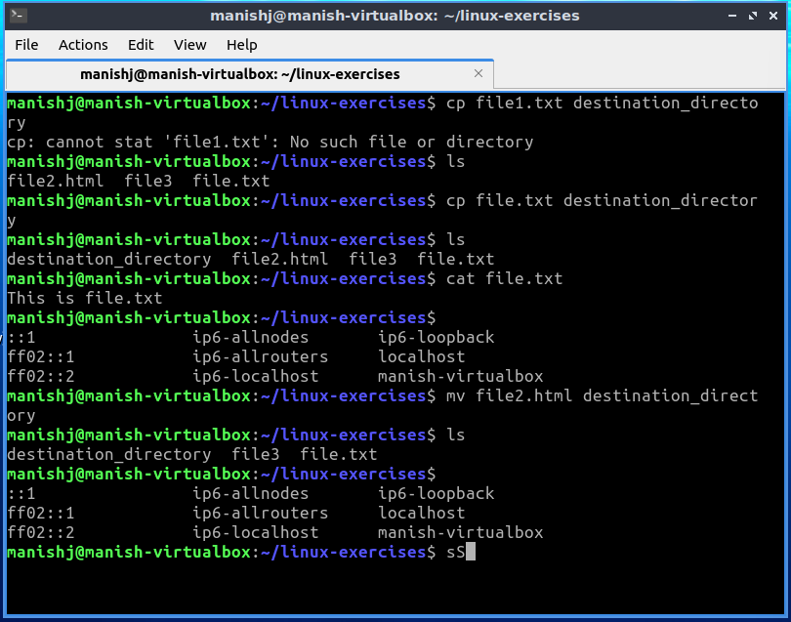

- WHOAMI – command is used to display the current user and our case it is - manishj
HISTORY – command is used to display a list of recently executed commands.
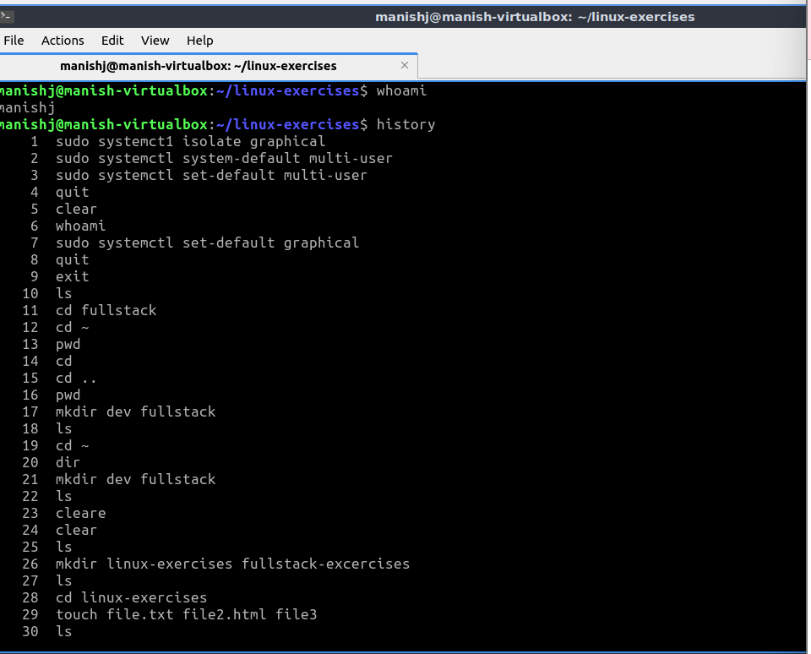

MAN - command is used to display the manual page. In the snapshot below, we used MAN WHOAMI and it shows the complete use and manual of the whoami command.
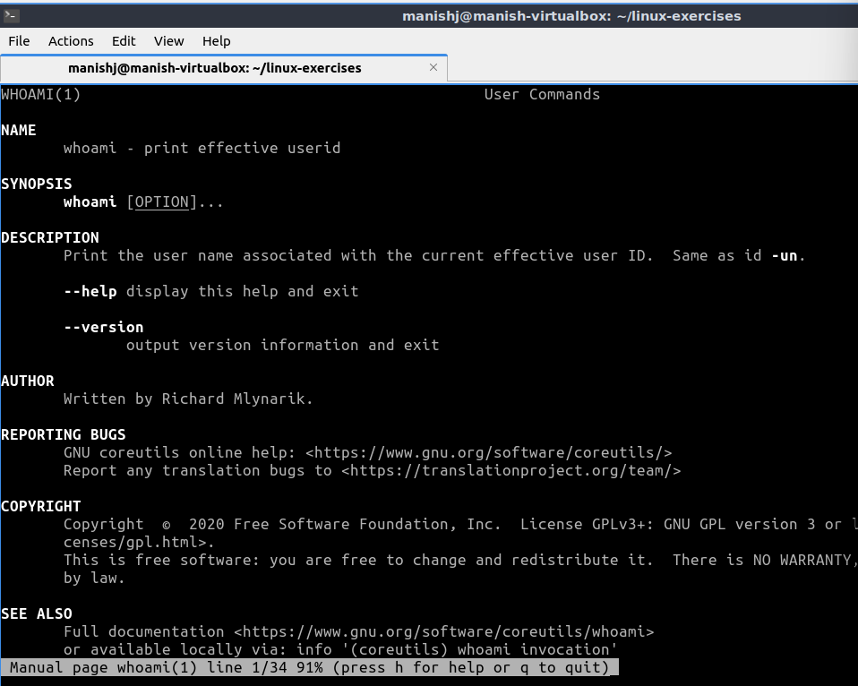
- SUDO APT UPDATE and SUDO APT UPGRADE command is used update the package lists for upgrades and upgrade command is used to install the available upgrades.
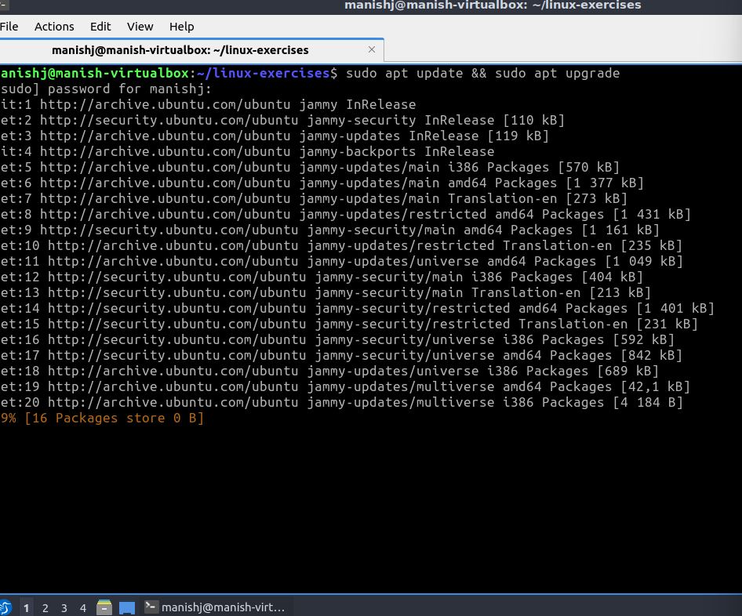
- SUDO APT INSTALL <PACKAGE_NAME> command is used to install the named binary package.
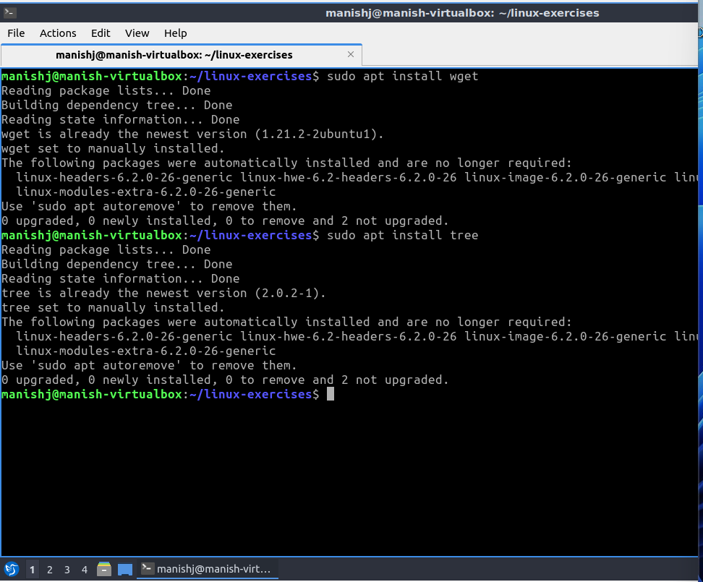
- PASSWD command is used to change the existing password of the current user.
